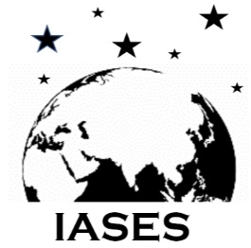
Institute of Astronomy Space and Earth Science
(Registered under West Bengal Society Registration Act, 1961, Nos. S0026037 of 2021-22)
Institute Off. P177, CIT Road, Scheme 7m, Kolkata 700 054
Mob.: +91-6290521079; Email: iases.2022@gmail.com

Your Recent
photograph

Membership Form

Ordinary Member Life Member

Name:
Address:
Phone Nos. / Email | Phone Nos. : Email :
Designation:
Aadhar Nos & Date of Birth :

* Subscription fees: Ordinary membership: Rs 1000/- for admission and Rs 200/- yearly there after. Life membership: Rs 5000/- one time. The membership fees are non-returnable.

** Membership will be granted subject to the decision of the management or governing body. Ordinary membership will be renewed every year subject to the approval of the management or governing body.

*** Interested individuals should fill up this form and send it to iases.2022@gmail.com . They will be notified about the subscription procedures through their email/mobile.

For office use (NOT to be filled up by the applicant):
It is to confirm that Dr./Ms./Mr. ……………………………………………………………………….. has been admitted as an ordinary/life member of Institute of Astronomy Space and Earth Science.

Secretary

